**Fonts and Text with Interactivity**

Demonstrations of using X3D’s <Text> and <FontStyle> nodes with JavaScript. To run these demonstrations, place the .ttf files into Android Studio’s assets folder, same location as texture maps and .x3d files.

**JS_Text_ChangeFontStyle.x3d**

Demonstrates rolling over labels changes the font style to Bold, Bold Italic (right image), italic or back to its initial Plain (left image).

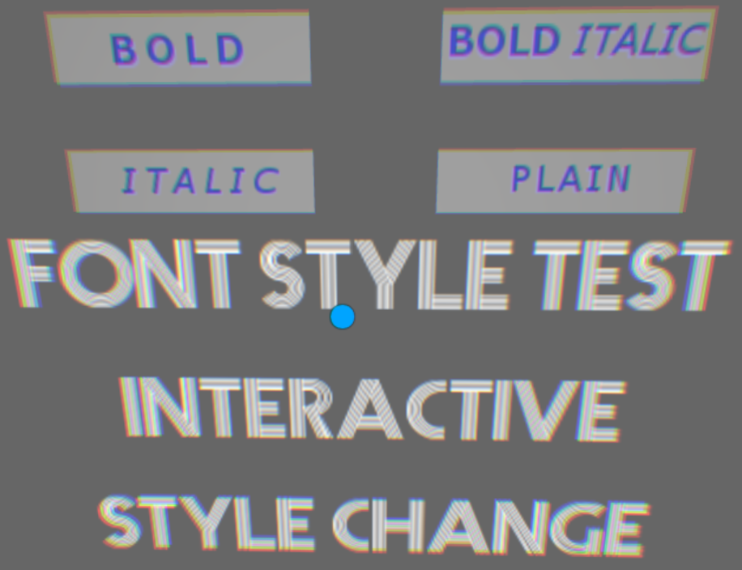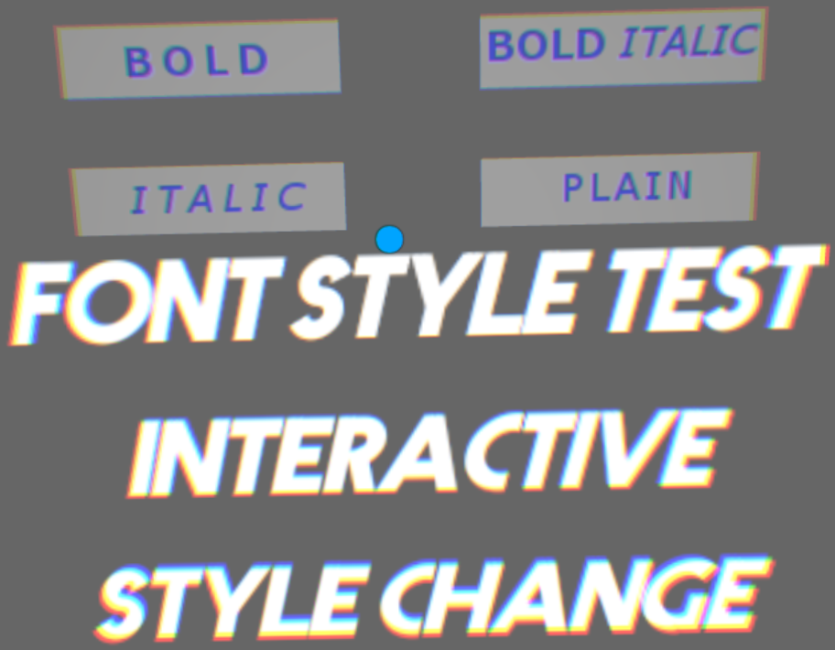

**JS_Text_ChangeText.x3d**

Demonstrates changing text. The text is animated just to radomize the test.

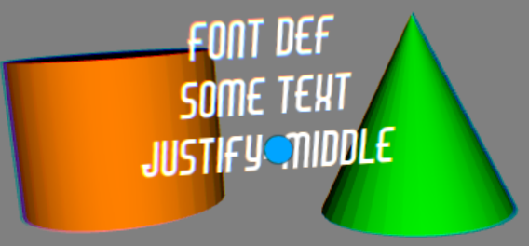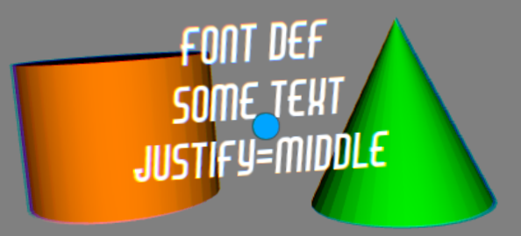

Rolling over the Cylinder changes the text to “Rolled Over Cylinder” and changes the Cone to yellow. Rolling over the Cone changes the test to “Cone Rolled Over” and cone to blue. The color changes to the Cone just randomizes the test.

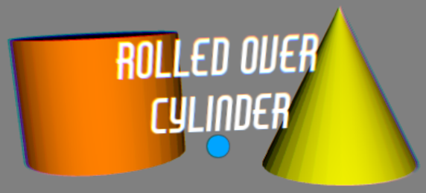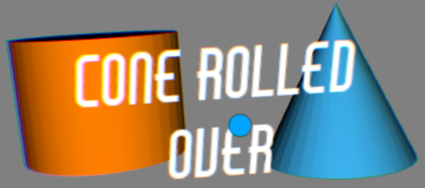

**JS_Text_ChangeText_PerFrame.x3d**

The text (in yellow) displays the time from the TimeSensor from 0 to 10 per frame. The Spher also has a procedural animation and color change but not synced to the TimeSensor, it just moves .4 units +/- along the X-axis between +/- 3. Rolling over the orange Cone changes the white text and its color to yellow. The Cone and Sphere just randomize the test.

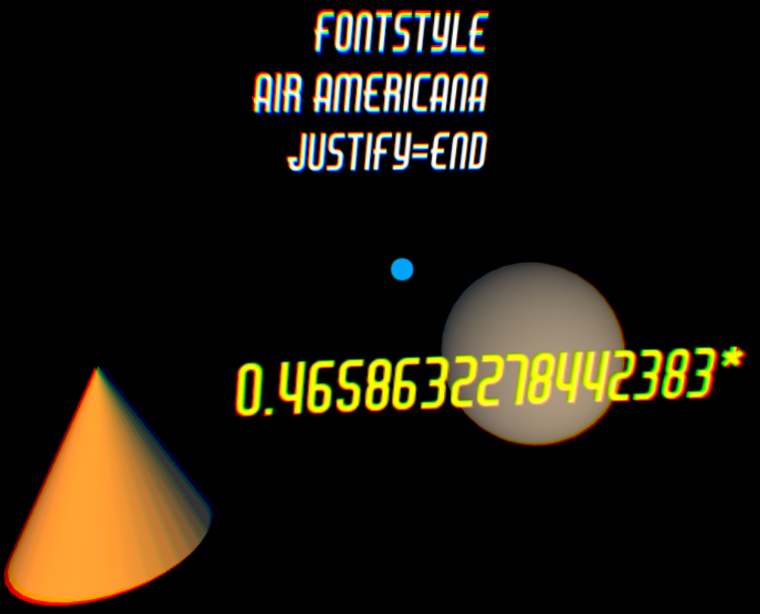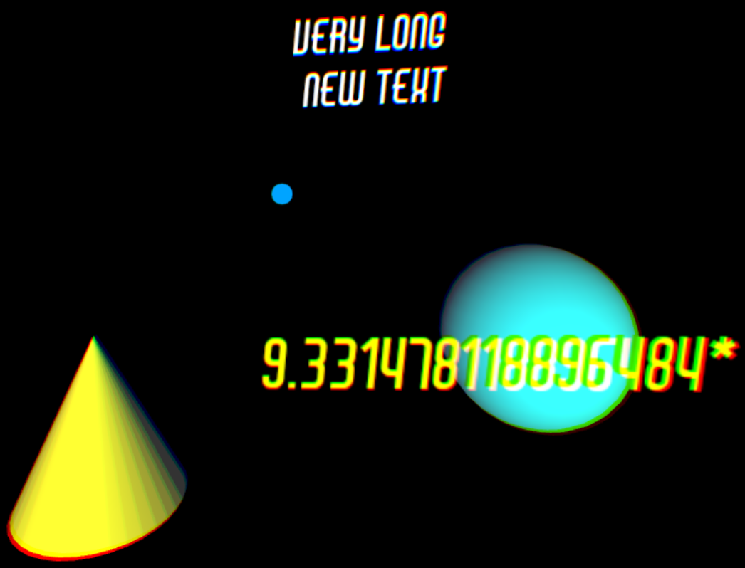

**JS_Text_Read_ChangeFontStyle.x3d**

The JavaScript in the demo reads the current style (PLAIN, BOLD, etc.) and changes it to another style:

PLAIN -> BOLD -> ITALIC -> BOLD ITALIC and back to PLAIN

